openssl enc -chacha20 -K 9f4c2b8a6e7d1f305ab93c0e42d67188c5f72a1d6b0e394f8caa2157d9e0b63c -iv 8a4f1c9d23e7b605d0a8c3f6b9124e7a -in manchester.jpg -out enmanchester.jpg
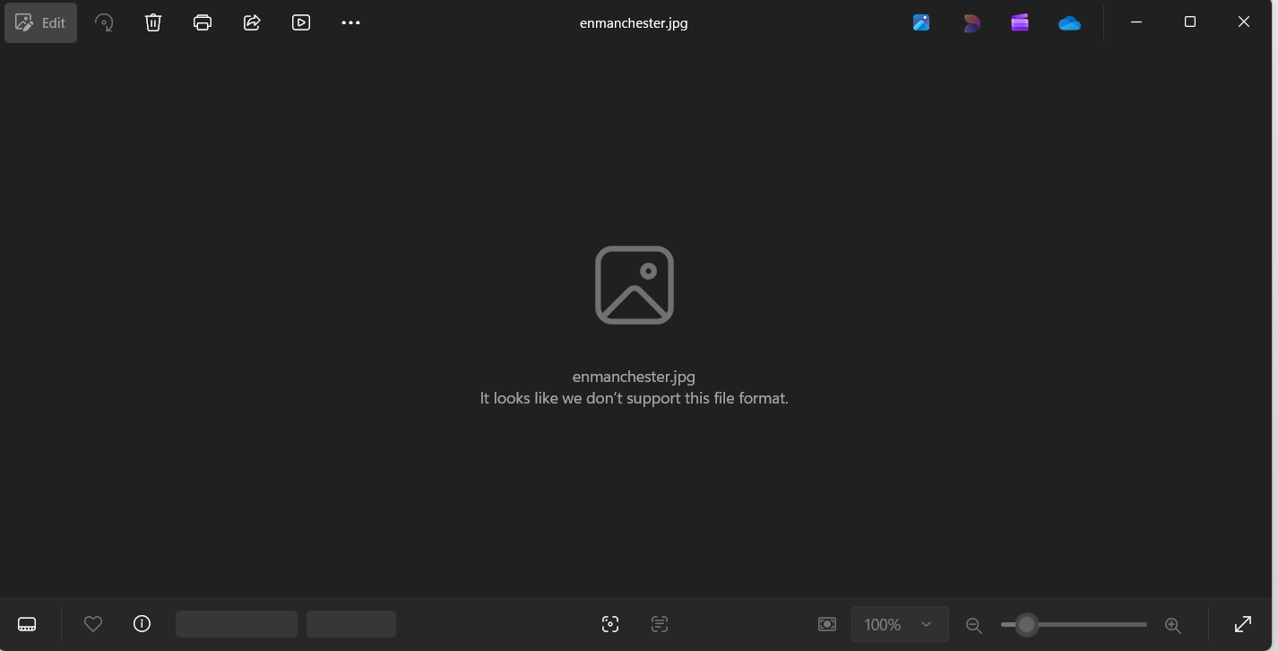

openssl enc -d -chacha20 -K 9f4c2b8a6e7d1f305ab93c0e42d67188c5f72a1d6b0e394f8caa2157d9e0b63c -iv 8a4f1c9d23e7b605d0a8c3f6b9124e7a -in enmanchester.jpg -out demanchester.jpg
start demanchester.jpg


